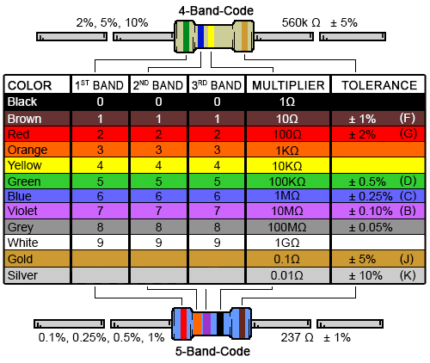

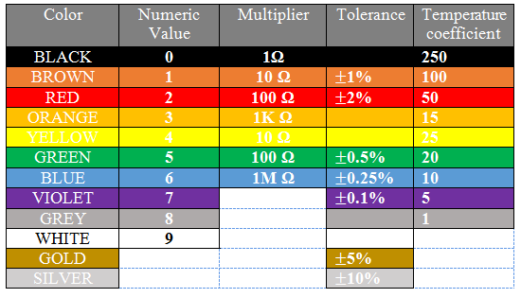

|  |  |  |
| --- | --- | --- |
| Resistance | 4 strips | 5 strips |
| 220 ohm |  |  |
| 330 ohm |  |  |
| 1K ohm |  |  |
| 10K ohm |  |  |
|  |  |  |

<https://circuitdigest.com/calculators/resistor-color-code-calculator>